

Datacenter to Azure Migration

Prepared for *Contoso-ICT*



Assessment Report / Proposal

Prepared by

*Bradley Stewart*

*Cloud Solution Architect*

*Contoso-ICT*

*05/03/2018*

Table of Contents

1 Introduction 3

2 Assessment 4

2.1 Business Overview 4

2.2 Business Case 5

2.3 Assessment Report 6

3 Proposal 7

3.1 Target State Architecture / Solution 8

3.1.1 Solution Components: 9

4 Why Microsoft Azure 10

5 Execution Strategy 13

5.1 Migration Approach 14

5.1.1 Timelines 14

5.1.2 Project Deliverables 15

5.1.3 Resources 15

5.1.4 Project Risk Management 16

5.1.5 Dependencies 16

5.1.6 Governance 17

6 Expected Results 18

6.1 Financial Benefits 18

6.2 Technical Benefits 18

6.3 Other Benefits 18

7 Costs / Pricing 19

8 Assumptions 21

9 Conclusion 22

1. Introduction

The cloud helps transform your business, giving you competitive advantage by enabling you to more freely innovate. Having a reliable partner to support your cloud journey can help you realize this potential and focus your resources on business growth.

*Contoso-ICT* offers *Cloud Migration* support across the Microsoft *Azure Cloud*, helping *Lucerne Publishing* update your business and accelerate the value of your on-premises and cloud-based software investments. Tailored to your unique business priorities, we deliver proactive and reactive services that enable you to minimize risk, reduce downtime, and lower support costs. Through our partnership with Microsoft, *Contoso-ICT* specializes in migrating workloads to Azure from a variety of platforms such as Hyper-V, VMware, and other public cloud providers, utilizing both Microsoft’s native tools and 3rd party solutions.

The purpose of this document is based on a follow-up from the assessments, workshops and interviews that was recently delivered on *Lucerne Publishing* infrastructure as part of the requirements gathering for the migration to Microsoft Azure Cloud Offering. It includes key findings, identified actions items with owners, specific next steps and timelines of execution. *Contoso-ICT* believes we have a greater understanding of the scope and complexity associated with this effort and believe that this proposal and proposed solution reflect that understanding.

*Contoso-ICT* can assist in the acceleration of implementation by utilizing prior project success and experience gained through similar engagements. Our team can provide technical, architectural, and overall project leadership expertise throughout the effort.

While this proposal is not meant to constitute a formal offer, acceptance, or contract, this proposal is furnished with the expectation that *Contoso-ICT* would have the opportunity to provide the services specified in this proposal under a mutually agreed set of terms and conditions. In the event that *Contoso-ICT* is selected to provide the products or services contemplated by this proposal, *Contoso-ICT* will negotiate in good faith with *Lucerne Publishing* to finalize any appropriate agreements not already in place.

1. Assessment
   1. Business Overview

*Lucerne Publishing is one of the largest English-language publishers in the world. With nearly 200 years of history, Lucerne has published some of the world’s foremost authors, including Nobel Prize, Pulitzer Prize, National Book Award, Newbery Medal and Caldecott Medal winners. Lucerne is consistently at the forefront of innovation, using digital technology to create unique reading and viewing experiences and expand the reach of its authors and documentary producers.*

*Lucerne is headquartered in New York City and has publishing groups in the United States, United Kingdom, Canada, Australia and New Zealand.*

|  |
| --- |
| Business Requirements |
| * *Identify the infrastructure requirements and plan for establishing a connection with Azure ExpressRoute that will support Lucerne’s migrated infrastructure.* * *Document the options for migrating the web tier to Azure keeping in mind that the configuration of the application will essentially be the same (supporting cookie affinity, etc.).* * *Create a migration plan for the database tier and ensure that the database will always be available even if a VM fails or during normal maintenance, such as patching monthly or when service packs are applied to the SQL Servers.* * *Understand how backup for this workload will work after migration (for application and compute workloads).* * *Prior to the migration, the procurement team should be able to perform a full test of the application running in Azure to ensure that it is fully functional.* * *Migration should be completed within a 12-hour window.* |

|  |  |  |  |  |
| --- | --- | --- | --- | --- |
| Business Goals |  | Success Metrics/KPI |  | Activities to achieve business goals |
| Cost Reduction |  | TCO Calculation vs Current TCO |  | Contoso-ICT to perform TCO calculation |
| Operational Flexibility |  | Ability to Provision / Deprovision services immediately |  | Contoso-ICT to Migrate Lucerne Publishing to Azure CSP model |

* 1. Business Case

*Contoso-ICT understands the business outcomes and metrics required by Lucerne Publishing, based on our meetings and workshops we understand the follow high-level objectives from the business case discussed:*

*Lucerne Publishing are seeking to lower TCO whilst still maintaining the same level of services and performance.*

*Lucerne Publishing are seeking increased flexibility from their I.T infrastructure. This should include the ability to turn services on and off, as required, and therefore only pay for the usage of services which they have consumed.*

*Lucerne Publishing are also seeking increased governance controls which support a more controlled I.T environment.*

*Minimal changes should be made to the existing server and application configuration.*

* 1. Assessment Report

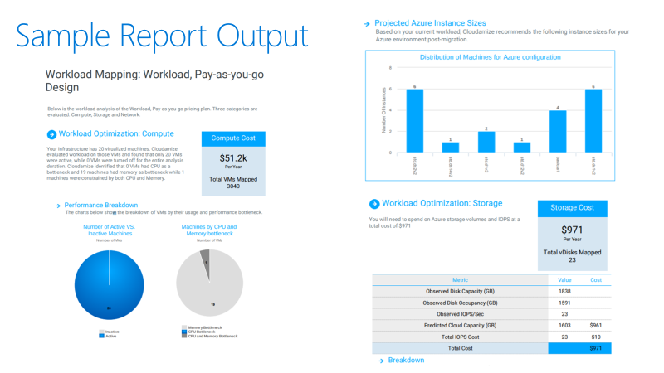

1. Proposal

*Contoso-ICT* is a Microsoft partner. Through this partnership we can leverage Microsoft’s resources, tools and training to offer you excellent professional services matched with Microsoft’s enterprise grade cloud services. This proposal is intended to outline our offer to migrate your requested datacenter servers and services to Azure.

We have designed this solution with both your requirements and Microsoft’s best practices in mind.

We have taken in consideration the requirements you outlined for us in your RFP, which are the following:

* Identify the infrastructure requirements and plan for establishing a connection with Azure ExpressRoute that will support Lucerne’s migrated infrastructure.
* Document the options for migrating the web tier to Azure keeping in mind that the configuration of the application will essentially be the same (supporting cookie affinity, etc.).
* Create a migration plan for the database tier and ensure that the database will always be available even if a VM fails or during normal maintenance, such as patching monthly or when service packs are applied to the SQL Servers.
* Understand how backup for this workload will work after migration (*for application and compute workloads*).
* Prior to the migration, the procurement team should be able to perform a full test of the application running in Azure to ensure that it is fully functional.
* The migration needs to be completed as quickly as possible but doesn’t have to be immediate. The customer can stand for a 12-hour outage window in which the system can be down for this one time move to the Cloud. That being said, Lucerne demands that there is a way to “fail back” if something goes wrong or they are outside of that 12-hour window.

* 1. Target State Architecture / Solution



* + 1. Solution Components:
* Azure D-Series VM Instances
* Availability Sets for each application tier
* Network Security Groups (NSG) for each subnet
* Managed Disks for all VM disks
* Application Gateway with WAF Detection mode enabled
* Azure IaaS VM backup
* VPN Gateway Express Route SKU
* Azure Security Center with Intrusion Detection capabilities enabled
* Operations Management Suite for environment monitoring
* SQL 2016 Always-On utilizing existing licenses (hybrid-benefit)

1. Why Microsoft Azure

Microsoft Azure is a world leader in cloud computing and offers the best-of-breed IaaS, PaaS, and SaaS services.

Azure’s global reach along with its enterprise grade security, services, and availability SLAs, ensure that your applications and services offer excellent performance and world class customer experience.

**Azure:**

1. Offers consumption-based pricing, you only pay for what you use. Flexibility is key, and now with Reserved Instances and Hybrid Use, Azure can offer substantial savings over on-premise and other public cloud providers.
2. Accelerates app innovation through rapid app development and agility in the cloud. Elastic scaling based upon your applications need for performance and PaaS services allow you to concentrate on your application code and business.
3. Delivers integrated data and intelligence—data for rich insights to intelligence embedded within apps.
4. Is open and flexible, where you can use the tools and technologies you already have and want to use. Supporting both Windows and Linux workloads and associated CICD tools, Azure is suitable for almost all workloads.
5. Is trusted to protect your business assets. As more customers expect digital experiences, they expect the data they share with an organization to be protected.

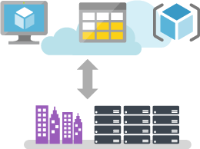

*Optimize your existing assets by taking a hybrid approach to the cloud. Azure offers hybrid consistency everywhere—in application development, security and management, identity management, and across the data platform. This helps reduce the risk and cost of a hybrid cloud environment by enabling a common set of skills and offering portability of applications and workloads.*

*Develop and build the way you want in Azure, with your choice of tools, applications, and frameworks, like Jenkins and Chef. As a leading open source contributor on GitHub, Microsoft actively supports multiple open source community projects—such as Kubernetes, fluentd, and Helm—and has a unique partnership with Red Hat to offer coordinated, multi-lingual support across multiple products.*

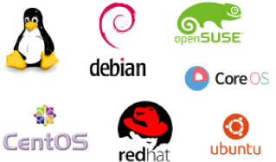

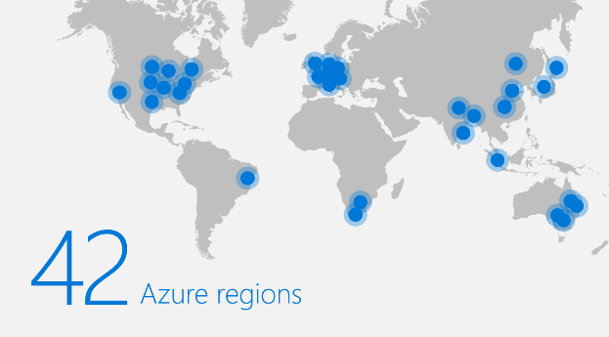

*Achieve global scale with 42 announced Azure regions—more than any other cloud provider. Azure’s priority on geographic expansion means you can choose the datacenter and region that’s right for you and your customers, with the performance and support you need, where you need it*

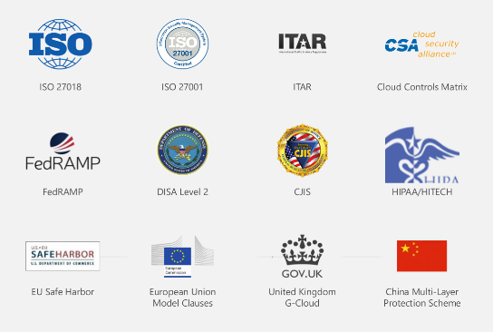

*Azure was the first major cloud provider to contractually commit to the requirements of the General Data Protection Regulation (GDPR). To protect your organization, Azure embeds security, privacy, and compliance into its development methodology, and has been recognized as the most trusted cloud for U.S. government institutions, earning a FedRAMP High authorization that covers 18 Azure services.*

1. Expected Results

We expect our proposed solution to Contoso-ICT to provide the following results:

* 1. Financial Benefits
* *Transfer from CapEx expenditure to monthly OpEx via Microsoft CSP agreement*
* *Decreased TCO*
* *Increased control over costs (based on consumption and the ability to turn-off services)*
  1. Technical Benefits
* *Enhanced flexibility and agility - Servers will be provisioned based on the performance required*
* *Enhanced security – WAF and Security Intrusion Detection will be deployed*
* *Higher availability – Solution has been designed with Microsoft 99.95% SLA*
* *Upgrade of Windows Operating Systems and SQL server applications as required*
* *Enhanced monitoring and reporting capabilities due to the deployment of OMS*
  1. Other Benefits
* *Enhanced Disaster Recovery services will now be available*
* *Global presence can be achieved by replicating and deploying to additional regions*

1. Costs / Pricing

The following table details the pricing for the hosting of the services outlined in this proposal. This pricing is valid for 30days from the date of this proposal but is subject to change based on Microsoft’s pricing changes.

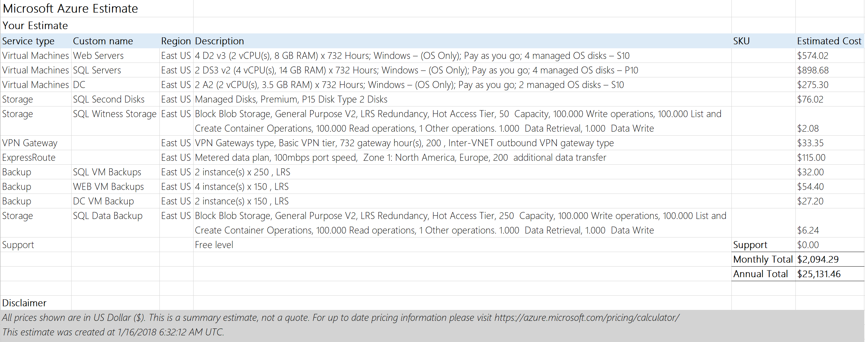*<Sample> Disclaimer: The prices listed in the preceding table are an estimate for the services discussed. This summary is not a warranty of final price. Estimates are subject to change if project specifications are changed or costs for outsourced services change. Cloud based services are charged based on consumption and are therefore variable depending on usage, we have taken this in to account and have provided pricing based on our expertise and experience.

The following table details the pricing for delivery of the services outlined in this proposal. This pricing is valid for 30 days from the date of this proposal:

|  |  |
| --- | --- |
| Services Cost Professional Services | Price (One-off) |
| Datacenter migration consultancy and migration | $20,000.00 |
| Total Services <Category #1> Costs | $20,000.00 |
| **Additional Services <Category #2>** |  |
| Professional Services to remediate servers ready for migration | $3,000.00 |
| Post-handover support (10 days) | $5,000.00 |
| Total Services <Category #2> Costs | $8,000.00 |
| Total | $28,000.00 |

1. Assumptions

The proposed solution is based on the follow assumptions:

* This proposal is based on the inventory supplied by Lucerne Publishing
* During this engagement process Microsoft has not made updates or changes which would require changes to the solution or its components
* Contoso-ICT has the full support required from Lucerne Publishing to execute the migration plan and all the associated activities

1. Conclusion

*Contoso-ICT* looks forward to working with *Contoso-ICT* and supporting your efforts to migrate to cloud-based services. *Contoso-ICT* is confident that we can meet the challenges ahead, and stand ready to partner with you in delivering effective cloud-based solutions

If you have questions on this proposal, feel free to contact *Bradley Stewart* at your convenience by email at *bradley.stewart@contosoICT.com* or by phone at *1800 554433.*   
  
*Contoso-ICT* will follow up with regards to next steps and discuss the proposal.

Thank you for your consideration,

*Bradley Stewart  
Cloud Solution Architect*